SDG Dashboard for Albania: A Quick Guide

Version 3.1 REL, 12 April 2018

# The scope of the Dashboard

Domestication/localization of SDGs requires setting up a Monitoring and Evaluation system, ideally through inclusion of SDG-related indicators into domestic strategic planning systems. A starting point in this process is global set of SDG indicators, developed by the Inter-Agency and Expert Group on SDG Indicators (IAEG-SDGs) and agreed to, as a practical starting point at the 47th session of the UN Statistical Commission held in March 2016[1]. While global indicators offer international yardstick for internationally agreed development agenda, the set could be insufficient for monitoring of situation in a country, as they prioritize international comparability at the expense of local adequacy, and aims at covering all targets at the expense of partial (or simply available) indicators[2]. In addition, just in a few instances Global indicators put forward specific targets to be achieved, and even in these cases targets are not country sensitive. The Dashboard makes a step towards country-wide adequate system through (i) identifying “official” international indicators[3] available for country[4]; (ii) identifying targets without indicators; and (iii) providing quick review of available country data for targets.

# SDG Dashboard Composition

SDG Dashboard consists of two spreadsheets, [SDG Dashboard Summary] and [SDG Dashboard].

## SDG Dashboard Summary

Indicators spreadsheet combines “official” international indicators and country indicators from several datasets. Each indicator is classified into one of four categories, using threshold:

* Green—target for 2030 achieved
* Yellow—target 2030 yet to be achieved, but intermediate target is achieved
* Red—intermediate target is not achieved.
* Gray—no indicator available for a target, or judgement is impossible

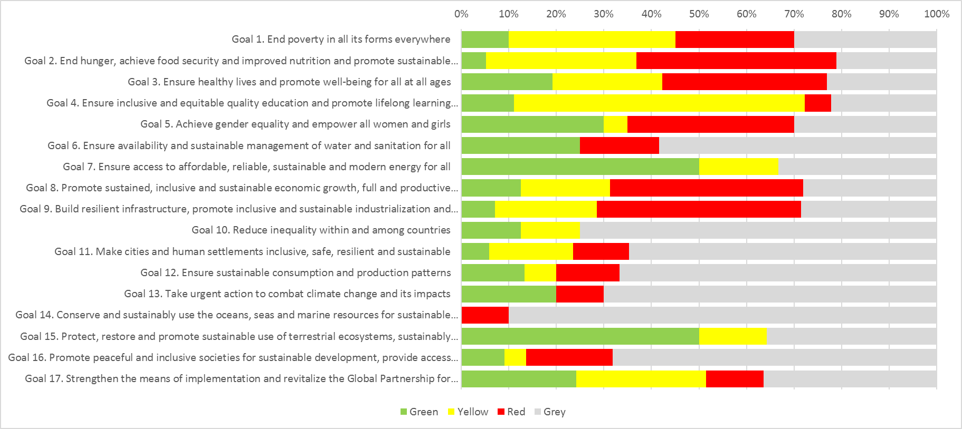

Each bar correspond to all indicators for each Goal, and Green, Yellow, Red and Gray segments correspond to share of indicators in each category. This information is summarized it table on the same sheet.

## SDG Dashboard

SDG Dashboard sheet contains detailed information for each indicator



**Goals and targets**—name of global indicators and targets

**Indicator**—name of indicator

**Availability**—is indicator available, Yes/No

**Indicator type**—type of indicator, according to the following classification:

* Global—global indicator without changes
* Global adjusted—The measured unit or the reference unit is different at national level
* Global split—too general indicators or ambiguity of definition, which required split into a few indicators
* Global proxy—the indicators differs, but they reveal general context of global indicators

**Trend**—spark chart showing trend in indicator

**Most recent**—most recent value of indicator

**Most recent status**—status of most recent value of indicator, assessed by schedule described above

**Target 2030**—target value for indicator for year 2030

**Intermediate target**—intermediary target value for indicator

**Direction**—desirable direction of indicator

* Positive—more is better, we would like to increase value of indicator, i.e. Enrollment rate
* Negative—more is worse we would like to increase value of indicator, i.e. Poverty rate

**Probability of achieving Target 2030**—probability of achieving target value, which is assessed based on projected level, using trend for 2007-2017. These projections should be treated with extreme caution, as often times they are based on very short trends, and past is not always good guidance for future. This probability is best visualized by SDG Tracker (see below). Probability is achieved by four points scale

* —projected level is equal or better than target 2030
* —projected level is equal or better than average between target 2030 and intermediate target
* —projected level is equal or better intermediate target
* —projected level is worse than intermediate target
* --projection is not possible

**EU Average, most recent**—most recent value of indicator for EU, if available; and year for which information available

## SDG Tracker

SDG Dashboard with interactive is available on-line here <http://bit.ly/2HijFsF>. It allow to see detailes of each indicator:



Tracker present data for each indicator for Albania and two comparators—EU and Croatia by default. Dotted line shows projected values for Albania. Bar at the right side of chart shows probability zones, as classified above.

1. See list of indicators here <http://unstats.un.org/sdgs/indicators/indicators-list/>
2. This is explicitly recognized ion the report of IAEG “Report of the Inter-Agency and Expert Group on

   Sustainable Development Goal Indicators” (<https://unstats.un.org/unsd/statcom/47th-session/documents/2016-2-IAEG-SDGs-E.pdf>):

   *22. […] The members also recognized that, in several cases, not all the multiple aspects of the targets are addressed by the indicators and that, in the long term, efforts will need to be made by the statistical community to identify indicators to complement the existing ones.23. The Expert Group also considered the relationship between the global indicators and the indicators for regional, national and subnational and thematic monitoring. It is expected that the global indicators will form the core of all other sets of indicators, especially considering that the discussions on the global indicators took into account some of the experience with regional, national and subnational and thematic monitoring. However, additional and in some cas es different indicators might be used for regional, national and subnational levels of monitoring. These indicators will be developed by Member States. Indicators for thematic monitoring are already being developed in a number of areas.*
3. The underlying assumption is that “official” international indicators collected and published by international organizations are based on country report, therefore availability of such indicator is a good proxy of country capacity to produce it. This assumption could be wrong. First, some indicators could be produced using other than national sources, for instance using mirror data. Second, some indicators could be not standardized, therefore available through country statistical system, but not through international databases.
4. Reliance on the “official” international indicators means SDG Dashboard face implementation issues in countries with weak statistical systems. In such